VISVESVARAYA TECHNOLOGICAL UNIVERSITY
“JnanaSangama”, Belgaum -590014, Karnataka.



LAB REPORT
on

BIG DATA ANALYTICS
(20CS6PEBDA)

Submitted by
Sailesh Prasad Ranjitkar(1BM19CS210)

in partial fulfillment for the award of the degree of
BACHELOR OF ENGINEERING
in
COMPUTER SCIENCE AND ENGINEERING



B.M.S. COLLEGE OF ENGINEERING
(Autonomous Institution under VTU)
BENGALURU-560019
May-2022 to July-2022

B.M.S. COLLEGE OF ENGINEERING

DEPARTMENT OF COMPUTER SCIENCE AND

ENGINEERING


CERTIFICATE


This is to certify that the Lab work entitled “BIG DATA ANALYTICS” carried out by Sailesh Prasad Ranjitkar(1BM19CS210), who is bonafide student of B. M. S. College of Engineering. It is in partial fulfillment for the award of Bachelor of Engineering in Computer Science and Engineering of the Visvesvaraya Technological University, Belgaum during the year 2022. The Lab report has been approved as it satisfies the academic requirements in respect of a BIG DATA ANALYTICS - (20CS6PEBDA) work prescribed for the said degree.

Prof. Pallavi GB Dr. Jyothi S Nayak
Assistant Professor Professor and Head
Department of CSE Department of CSE
BMSCE, Bengaluru BMSCE, Bengaluru

1

Table of Contents

S. No. | Programme | Page No.
1 | Cassandra Operations - Employee Keyspace | 3-5
2 | Cassandra Operations - Library Keyspace | 6-8
3 | MongoDB Operations | 9-12
4 | Hadoop Installation | 13-14
5 | Hadoop Operations - Word Count | 15
6.1 | Hadoop Operations - Average Temperature | 16-20
6.2 | Hadoop Operations - Mean Max | 20-23
 | Temperature
7 | Hadoop Operations - Sort Words | 24-30
8 | Hadoop Operations - Join Demonstration | 31-39
9 | Spark Installation | 40
10 | Spark Operations - Word Count | 41-43
 | Table. 1

2

Lab -1

Programme -1

Cassandra Operations on Employee Keyspace

cqlsh> DESCRIBE Employee;

cqlsh> CREATE KEYSPACE Employee with replication={'class':'SimpleStrategy', 'replication_factor':1};

CREATE KEYSPACE employee WITH replication = {'class': 'SimpleStrategy',

'replication_factor': '1'} AND durable_writes = true;

cqlsh> USE Employee;

cqlsh:employee> CREATE TABLE employee_info (emp_id int primary key, emp_name text, designation text, doj timestamp, salary double, dept_name text);

cqlsh:employee> DESCRIBE TABLE employee_info
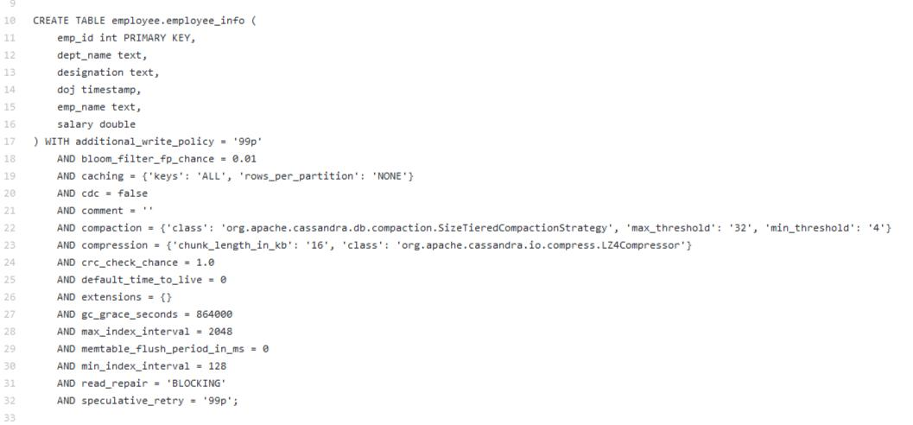

Fig. 1

cqlsh:employee> BEGIN BATCH

... INSERT INTO employee_info (emp_id, emp_name, designation, doj, salary,

dept_name) VALUES (031, 'David Sheen', 'Developer', '2019-02-11', 86000.00, 'Development')

... INSERT INTO employee_info (emp_id, emp_name, designation, doj, salary,

dept_name) VALUES (130, 'Sara Sheen', 'Developer', '2019-03-11', 96000.00, 'Development')

3

... INSERT INTO employee_info (emp_id, emp_name, designation, doj, salary, dept_name) VALUES (121, 'Maria DS', 'Manager', '2018-02-11', 186000.00, 'Sales')

... APPLY BATCH;

cqlsh:employee> SELECT * from employee_info;
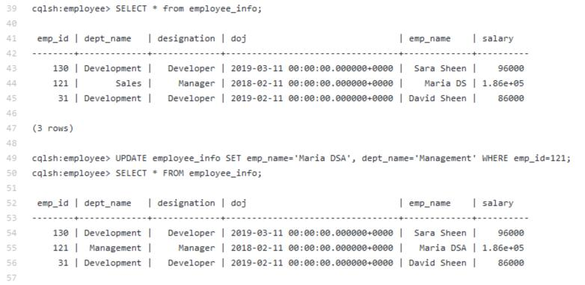

Fig. 2

cqlsh:employee> ALTER TABLE employee_info ADD projects set<text>;

cqlsh:employee> SELECT * FROM employee_info;
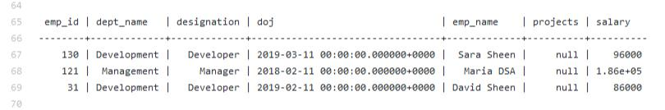

Fig. 3

cqlsh:employee> UPDATE employee_info SET projects={'LMS', 'Notin'} WHERE emp_id=121;

cqlsh:employee> UPDATE employee_info SET projects={'ECommerce', 'Gadgets Site', 'Travel Blog'} WHERE emp_id=031;cqlsh:employee>

cqlsh:employee> UPDATE employee_info SET projects={'E-Commerce', 'Journal Blog'} WHERE emp_id=130;

cqlsh:employee> SELECT * FROM employee_info;

4

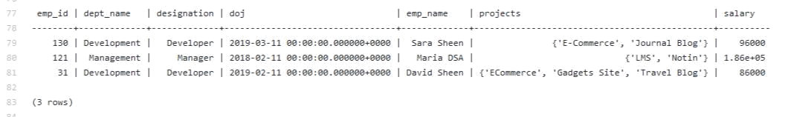

Fig. 4

cqlsh:Employee> BEGIN BATCH

... INSERT INTO

employee_info(Emp_Id,Emp_Name,Designation,Date_Of_joining,Salary,Dept_Name,projects)

VALUES(124,'Joe','Intern','2021-03-20',25000,'IT',{'LMS'}) USING TTL 15

... APPLY BATCH;

cqlsh:Employee> SELECT * FROM employee_info;
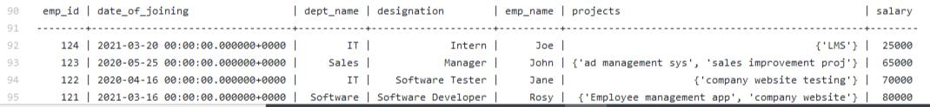

Fig. 5

cqlsh:Employee> SELECT * FROM employee_info;
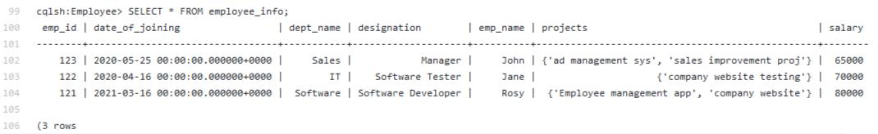

Fig. 6

5

Lab -2

Programme -2

Cassandra Operations on Library Keyspace

cqlsh> CREATE KEYSPACE "Library" WITH REPLICATION = { 'class':'SimpleStrategy', 'replication_factor':1};

cqlsh> USE "Library";

cqlsh:Library> DESCRIBE TABLE Library_Info;
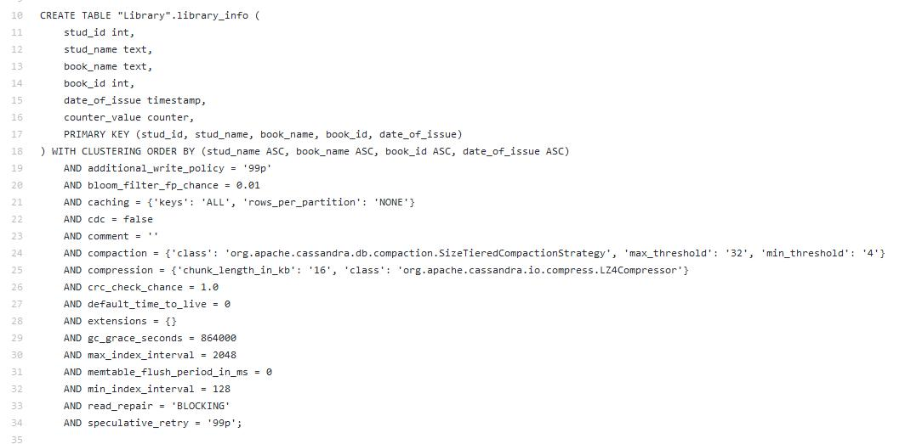

Fig. 7

cqlsh:Library> UPDATE Library_Info SET Counter_value=Counter_value+1 where Stud_Id=1 and Stud_Name='Anusree' and Book_name='BDA' and Book_id=111 and Date_Of_Issue='2021-03-15';

cqlsh:Library> UPDATE Library_Info SET Counter_value=Counter_value+1 where Stud_Id=2 and Stud_Name='Priya' and Book_name='OOMD' and Book_id=112 and Date_Of_Issue='2021-02-12';

cqlsh:Library> UPDATE Library_Info SET Counter_value=Counter_value+1 where Stud_Id=112 and Stud_Name='Aswin' and Book_name='BDA' and Book_id=1123 and Date_Of_Issue='2021-01-18';

6

cqlsh:Library> SELECT * FROM Library_Info;
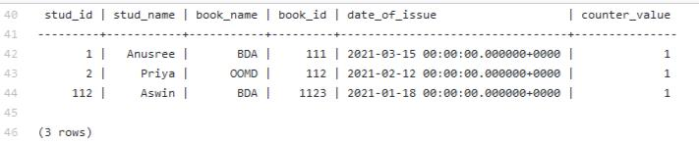

Fig. 8

cqlsh:Library> UPDATE Library_Info SET Counter_value=Counter_value+1 where Stud_Id=112 and Stud_Name='Aswin' and Book_name='BDA' and Book_id=1123 and Date_Of_Issue='2021-01-18';

cqlsh:Library> SELECT * FROM Library_Info;
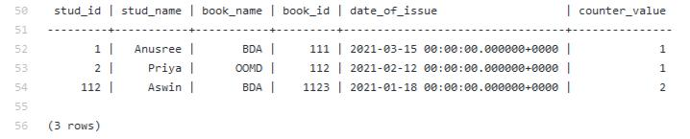

Fig. 9

cqlsh:Library> COPY

Library_Info(Stud_Id,Stud_Name,Book_Name,Book_Id,Date_Of_Issue,Counter_value) TO 'g:\libraryInfo.csv';

Using 1 child processes

Starting copy of Library.library_info with columns [stud_id, stud_name, book_name, book_id, date_of_issue, counter_value].

cqlshlib.copyutil.ExportProcess.write_rows_to_csv(): writing row

cqlshlib.copyutil.ExportProcess.write_rows_to_csv(): writing row

cqlshlib.copyutil.ExportProcess.write_rows_to_csv(): writing row

Processed: 3 rows; Rate: 6 rows/s; Avg. rate: 6 rows/s

7

3 rows exported to 1 files in 0.484 seconds.

cqlsh:Library> CREATE TABLE Library_Info_Import( Stud_Id int, Counter_value counter, Stud_Name text, Book_Name text, Book_Id int, Date_Of_Issue timestamp, PRIMARY KEY(Stud_Id,Stud_Name,Book_Name,Book_Id,Date_Of_Issue));cqlsh:Library> COPY Library_Info_Import(Stud_Id,Stud_Name,Book_Name,Book_Id,Date_Of_Issue,Counter_value) FROM 'g:\libraryInfo.csv';

Using 1 child processes

Starting copy of Library.library_info_import with columns [stud_id, stud_name, book_name, book_id, date_of_issue, counter_value].

Processed: 3 rows; Rate: 6 rows/s; Avg. rate: 8 rows/s

3 rows imported from 1 files in 0.365 seconds (0 skipped).

cqlsh:Library> SELECT * FROM Library_Info_Import;
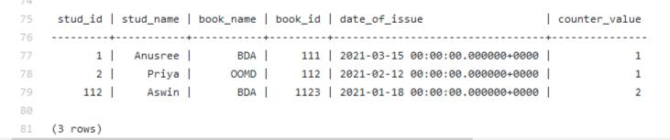

Fig. 9

8

Lab -3

Programme -3

MongoDB operations

- create db use student

- create collection db.createCollection("student") show collections

- insert into collection db.student.insert({

rollNo: 19,

age: 18,

contact: 1234567890,

emailID: "vineeth.cse@bmsce.ac.in"

})

db.student.find().pretty()

- inserting multiple db.student.insertMany([

{

rollNo: 18,

age: 18,

contact: 1234567890,

emailID: "kavya.cse@bmsce.ac.in" },

{

rollNo: 10,

age: 18,

contact: 1234567890,

9

emailID: "sanjay.cse@bmsce.ac.in"

},

{

rollNo: 31,

age: 18,

contact: 1234567890,

emailID: "nanma.cse@bmsce.ac.in"

}

])

//deleting a row

db.student.remove({

rollNo: 18,

age: 18,

contact: 1234567890,

emailID: "kavya.cse@bmsce.ac.in"

})

db.student.find().pretty()

db.student.updateOne({rollNo:10},

{$set: {emailID:"sanjana.cse@bmsce.ac.in"}})

//find specific

db.student.find({rollNo:10}).pretty()

//insert and then replace

db.student.insert({

rollNo: 11,

age: 18,

contact: 1234567890,

emailID: "abc.cse@bmsce.ac.in",

name: "ABC"

10

})

db.student.replaceOne({rollNo:11},

{

rollNo:11,

age: 18,

contact: 1234567890,

emailID: "abc.cs@bmsce.ac.in",

name: "FEM"

})

db.student.find({rollNo:11}).pretty()

//find all

db.student.find().pretty()

//export

mongoexport--db=student

--collection=student

--type=csv

--fields=rollNo, age, contactNo, emailID, name --out=C:\Softwares\mongodbOutput\students.csv
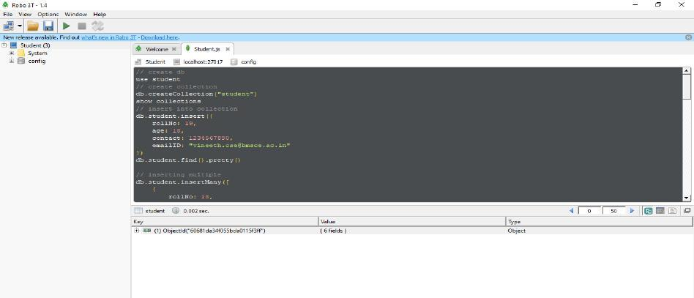

Fig. 10

11

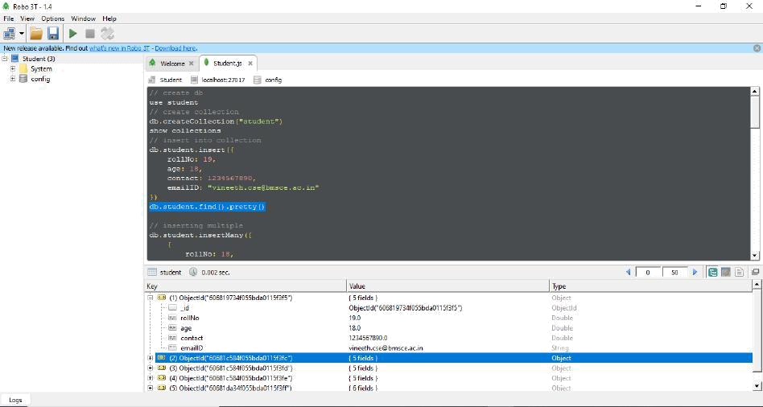

Fig. 11
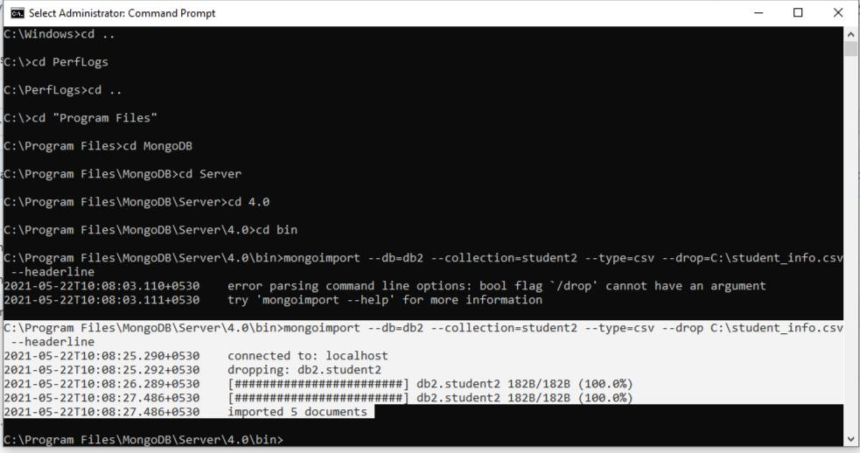

Fig. 12

12

Lab -4

Programme -4

Hadoop Installation

- hadoop version Hadoop 2.9.0

Subversion https://git-wip-us.apache.org/repos/asf/hadoop.git -r 756ebc8394e473ac25feac05fa493f6d612e6c50

Compiled by arsuresh on 2017-11-13T23:15Z

Compiled with protoc 2.5.0

From source with checksum 0a76a9a32a5257331741f8d5932f183

This command was run using

/usr/local/hadoop/share/hadoop/common/hadoop-common-2.9.0.jar

$ hadoop fs -cat /geeks/exampleFile2.txt

This is an example file. We are working with hadoop. Hadoop is used for Big Data $ hadoop fs -ls /geeks

21/04/17 13:53:37 WARN util.NativeCodeLoader: Unable to load native-hadoop library for your platform... using builtin-java classes where applicable

Found 1 items

-rw-r--r-- 1 hadoopusr supergroup 83 2021-04-17 13:52 /geeks/exampleFile2.txt

- hadoop fs -put exampleFile2.txt /geeks

- hadoop fs -mkdir /dir

- hadoop fs -ls /

21/04/17 14:03:05 WARN util.NativeCodeLoader: Unable to load native-hadoop library for your platform... using builtin-java classes where applicable

Found 4 items
-rw-r--r-- | 1 hadoopusr supergroup | 0 2021-04-17 | 13:33 /ap.txt
drwxr-xr-x | - hadoopusr supergroup | 0 2021-04-17 | 14:01 /dir
drwxr-xr-x | - hadoopusr supergroup | 0 2021-04-17 | 12:33 /directory1
drwxr-xr-x | - hadoopusr supergroup | 0 2021-04-17 | 13:52 /geeks

13

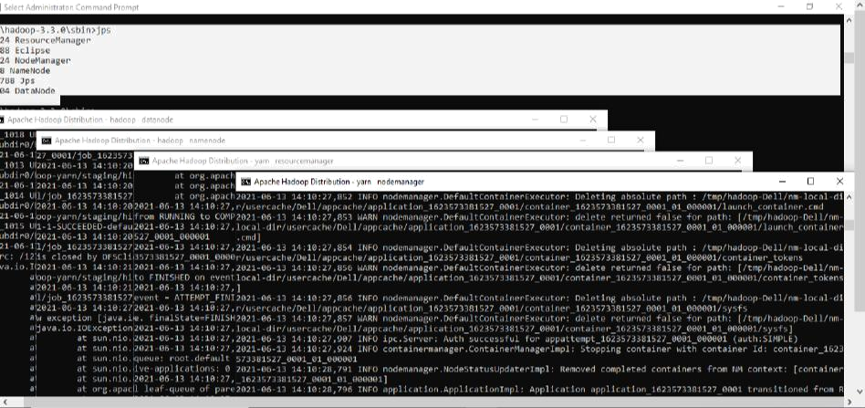

Fig. 13

14

Lab -5

Programme -5

Hadoop Operations - Word Count

Commands

hdfs namenode -format //optional

cd hadoop-3.3.0/sbin

start-dfs

start-yarn

jps

hdfs dfs -mkdir /input_dir

hdfs dfs -ls /

hdfs dfs -copyFromLocal D:\input_file.txt /input_dir hdfs dfs -cat /input_dir/input_file.txt // download MapReduceClient.jar

hadoop jar D:\MapReduceClient.jar wordcount /input_dir /output_dir hdfs dfs -cat /output_dir/*
Input File

Hello World

Hi World

Hello World

Wassup World
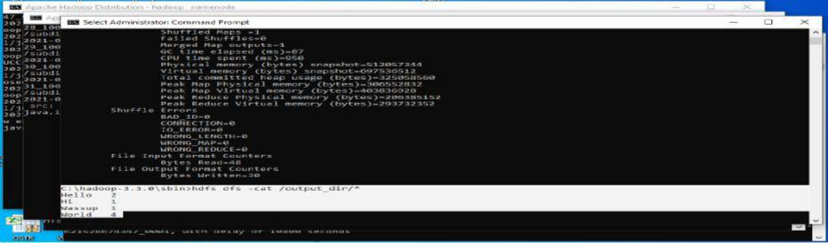

Fig. 14

15

Lab -6

Programme -6

Hadoop Operations - Temperature Manipulations

Average Temperature

Driver Class

import org.apache.hadoop.io.*;

import org.apache.hadoop.fs.*;

import org.apache.hadoop.mapreduce.*;

import org.apache.hadoop.mapreduce.lib.input.FileInputFormat;

import org.apache.hadoop.mapreduce.lib.output.FileOutputFormat;

public class AverageDriver

{

public static void main (String[] args) throws Exception {

if (args.length != 2)

{

System.err.println("Please Enter the input and output parameters"); System.exit(-1);

}

Job job = new Job();

job.setJarByClass(AverageDriver.class);

job.setJobName("Max temperature");

FileInputFormat.addInputPath(job,new Path(args[0]));

FileOutputFormat.setOutputPath(job,new Path (args[1]));

job.setMapperClass(AverageMapper.class);

job.setReducerClass(AverageReducer.class);

job.setOutputKeyClass(Text.class);

job.setOutputValueClass(IntWritable.class);

System.exit(job.waitForCompletion(true)?0:1);

16

}

}

Mapper Class

import org.apache.hadoop.io.*;

import org.apache.hadoop.mapreduce.*;

import java.io.IOException;

public class AverageMapper extends Mapper <LongWritable, Text, Text, IntWritable>

{

public static final int MISSING = 9999;

public void map(LongWritable key, Text value, Context context) throws IOException, InterruptedException

{

String line = value.toString();

String year = line.substring(15,19);

int temperature;

if (line.charAt(87)=='+')

temperature = Integer.parseInt(line.substring(88, 92));

else

temperature = Integer.parseInt(line.substring(87, 92)); String quality = line.substring(92, 93);

if(temperature != MISSING && quality.matches("[01459]")) context.write(new Text(year),new IntWritable(temperature));

}

}

17

Reducer Class

import org.apache.hadoop.io.IntWritable;

import org.apache.hadoop.io.Text;

import org.apache.hadoop.mapreduce.*;

import java.io.IOException;

public class AverageReducer extends Reducer <Text, IntWritable,Text, IntWritable >

{

public void reduce(Text key, Iterable<IntWritable> values, Context context) throws

IOException, InterruptedException

{

int max_temp = 0;

int count = 0;

for (IntWritable value : values)

{

max_temp += value.get();

count+=1;

}

context.write(key, new IntWritable(max_temp/count));

}

}

18

Input File -temp.txt
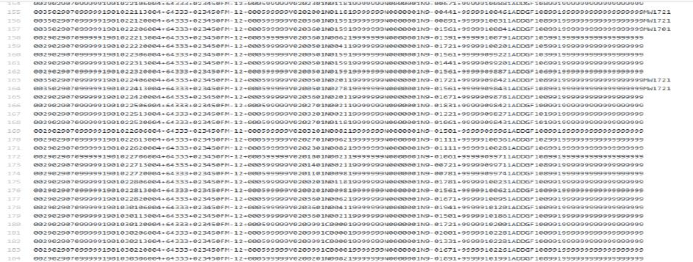

Fig. 15
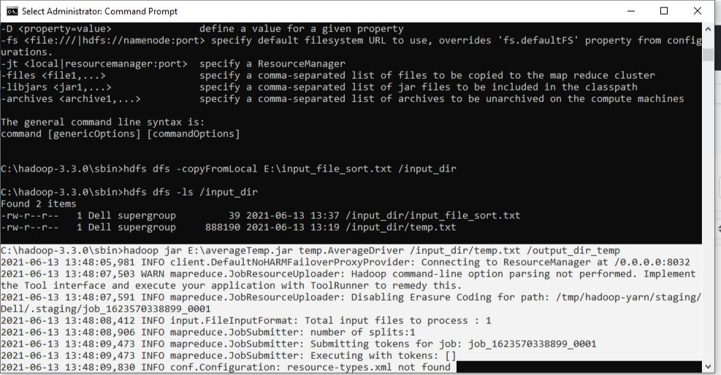

Fig. 16

19

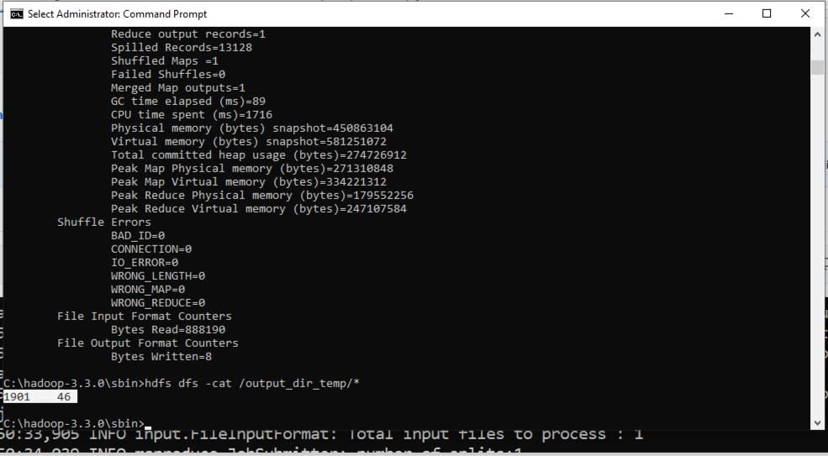

Fig. 17

Mean Max Temperature

Driver Class

package meanMaxTemp;

import org.apache.hadoop.io.*;

import org.apache.hadoop.fs.*;

import org.apache.hadoop.mapreduce.*;

import org.apache.hadoop.mapreduce.lib.input.FileInputFormat;

import org.apache.hadoop.mapreduce.lib.output.FileOutputFormat;

public class MeanMaxDriver

{

public static void main (String[] args) throws Exception {

if (args.length != 2)

{

System.err.println("Please Enter the input and output parameters"); System.exit(-1);

20

}

Job job = new Job();

job.setJarByClass(MeanMaxDriver.class);

job.setJobName("Max temperature");

FileInputFormat.addInputPath(job,new Path(args[0]));

FileOutputFormat.setOutputPath(job,new Path (args[1]));

job.setMapperClass(MeanMaxMapper.class);

job.setReducerClass(MeanMaxReducer.class);

job.setOutputKeyClass(Text.class);

job.setOutputValueClass(IntWritable.class);

System.exit(job.waitForCompletion(true)?0:1);

}

}

Mapper Class

package meanMaxTemp;

import org.apache.hadoop.io.*;

import org.apache.hadoop.mapreduce.*;

import java.io.IOException;

public class MeanMaxMapper extends Mapper<LongWritable, Text, Text, IntWritable> { public static final int MISSING = 9999;

public void map(LongWritable key, Text value, Context context) throws IOException, InterruptedException

{

String line = value.toString();

String month = line.substring(19,21);

int temperature;

if (line.charAt(87)=='+')

temperature = Integer.parseInt(line.substring(88, 92));

else

21

temperature = Integer.parseInt(line.substring(87, 92)); String quality = line.substring(92, 93);

if(temperature != MISSING && quality.matches("[01459]")) context.write(new Text(month),new IntWritable(temperature));

}

}

Reducer Class

package meanMaxTemp;

import org.apache.hadoop.io.IntWritable;

import org.apache.hadoop.io.Text;

import org.apache.hadoop.mapreduce.*;

import java.io.IOException;

public class MeanMaxReducer extends Reducer <Text, IntWritable, Text, IntWritable>{

public void reduce(Text key, Iterable<IntWritable> values, Context context) throws IOException, InterruptedException {

int max_temp = 0;

int total_temp = 0;

int count = 0;

int days = 0;

for(IntWritable value: values) {

int temp = value.get();

if(temp > max_temp) {

max_temp = temp;

}

count+=1;

if(count == 3) {

total_temp += max_temp;

max_temp = 0;

count = 0;

22

days += 1;

}

}

context.write(key, new IntWritable(total_temp/days));

}

}
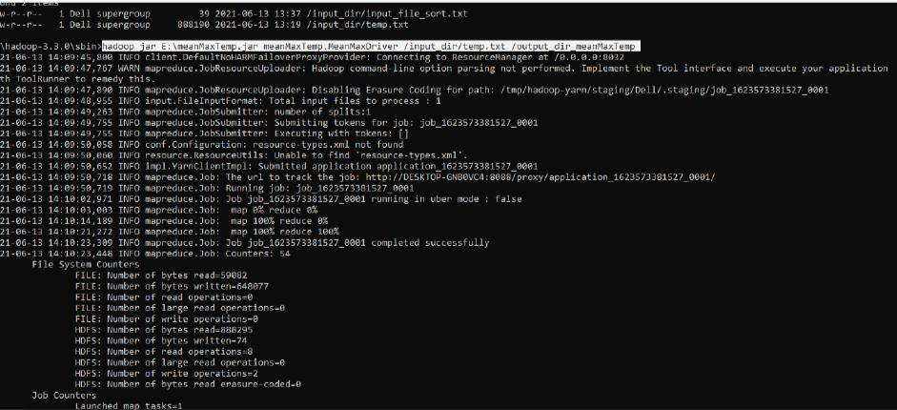

Fig. 18
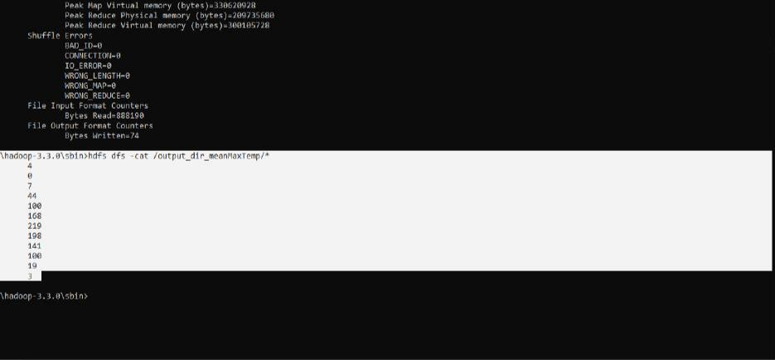

Fig. 19

23

Lab -7

Programme -7

Hadoop Operations - Sort words

Driver Class

package hadoopSort;

import java.io.IOException;

import java.util.StringTokenizer;

import org.apache.hadoop.conf.Configuration;

import org.apache.hadoop.fs.Path;

import org.apache.hadoop.io.IntWritable;

import org.apache.hadoop.io.Text;

import org.apache.hadoop.mapreduce.Job;

import org.apache.hadoop.mapreduce.Mapper;

import org.apache.hadoop.mapreduce.lib.input.FileInputFormat; import org.apache.hadoop.mapreduce.lib.output.FileOutputFormat; import org.apache.hadoop.util.GenericOptionsParser; public class TopN {

public static void main(String[] args) throws Exception { Configuration conf = new Configuration();

String[] otherArgs = new GenericOptionsParser(conf, args).getRemainingArgs();

if (otherArgs.length != 2) {

System.err.println("Usage: TopN <in> <out>");

System.exit(2);

}

Job job = Job.getInstance(conf);

job.setJobName("Top N");

job.setJarByClass(TopN.class);

job.setMapperClass(TopNMapper.class);

//job.setCombinerClass(TopNReducer.class);

24

job.setReducerClass(TopNReducer.class);

job.setOutputKeyClass(Text.class); job.setOutputValueClass(IntWritable.class); FileInputFormat.addInputPath(job, new Path(otherArgs[0])); FileOutputFormat.setOutputPath(job, new Path(otherArgs[1])); System.exit(job.waitForCompletion(true) ? 0 : 1); }

/**

- The mapper reads one line at the time, splits it into an array of single words and emits every

- word to the reducers with the value of 1.

*/

public static class TopNMapper extends Mapper<Object, Text, Text, IntWritable> { private final static IntWritable one = new IntWritable(1); private Text word = new Text();

private String tokens = "[_|$#<>\\^=\\[\\]\\*/\\\\,;,.\\-:()?!\"']"; @Override

public void map(Object key, Text value, Context context) throws IOException, InterruptedException {

String cleanLine = value.toString().toLowerCase().replaceAll(tokens, " "); StringTokenizer itr = new StringTokenizer(cleanLine); while (itr.hasMoreTokens()) {

word.set(itr.nextToken().trim());

context.write(word, one);

}

}

}

}

25

Combiner Class

package hadoopSort;

import org.apache.hadoop.conf.Configuration;

import org.apache.hadoop.fs.Path;

import org.apache.hadoop.io.IntWritable;

import org.apache.hadoop.io.Text;

import org.apache.hadoop.mapreduce.Job;

import org.apache.hadoop.mapreduce.Mapper;

import org.apache.hadoop.mapreduce.Reducer;

import org.apache.hadoop.mapreduce.lib.input.FileInputFormat; import org.apache.hadoop.mapreduce.lib.output.FileOutputFormat; import org.apache.hadoop.util.GenericOptionsParser; import utils.MiscUtils;

import java.io.IOException;

import java.util.HashMap;

import java.util.Map;

import java.util.StringTokenizer;

public class TopNCombiner extends Reducer<Text, IntWritable, Text, IntWritable> { @Override

public void reduce(Text key, Iterable<IntWritable> values, Context context) throws IOException, InterruptedException {

- computes the number of occurrences of a single word int sum = 0;

for (IntWritable val : values) { sum += val.get();

}

context.write(key, new IntWritable(sum));

}

26

}

Mapper Class

package hadoopSort;

import org.apache.hadoop.conf.Configuration;

import org.apache.hadoop.fs.Path;

import org.apache.hadoop.io.IntWritable;

import org.apache.hadoop.io.Text;

import org.apache.hadoop.mapreduce.Job;

import org.apache.hadoop.mapreduce.Mapper;

import org.apache.hadoop.mapreduce.Reducer;

import org.apache.hadoop.mapreduce.lib.input.FileInputFormat; import org.apache.hadoop.mapreduce.lib.output.FileOutputFormat; import org.apache.hadoop.util.GenericOptionsParser; import utils.MiscUtils;

import java.io.IOException;

import java.util.HashMap;

import java.util.Map;

import java.util.StringTokenizer;

public class TopNMapper extends Mapper<Object, Text, Text, IntWritable> { private final static IntWritable one = new IntWritable(1); private Text word = new Text();

private String tokens = "[_|$#<>\\^=\\[\\]\\*/\\\\,;,.\\-:()?!\"']"; @Override

public void map(Object key, Text value, Context context) throws IOException, InterruptedException {

String cleanLine = value.toString().toLowerCase().replaceAll(tokens, " "); StringTokenizer itr = new StringTokenizer(cleanLine); while (itr.hasMoreTokens()) {

word.set(itr.nextToken().trim());

27

context.write(word, one);

}

}

}

Reducer Class

package hadoopSort;

import org.apache.hadoop.conf.Configuration;

import org.apache.hadoop.fs.Path;

import org.apache.hadoop.io.IntWritable;

import org.apache.hadoop.io.Text;

import org.apache.hadoop.mapreduce.Job;

import org.apache.hadoop.mapreduce.Mapper;

import org.apache.hadoop.mapreduce.Reducer;

import org.apache.hadoop.mapreduce.lib.input.FileInputFormat; import org.apache.hadoop.mapreduce.lib.output.FileOutputFormat; import org.apache.hadoop.util.GenericOptionsParser; import utils.MiscUtils;

import java.io.IOException;

import java.util.HashMap;

import java.util.Map;

import java.util.StringTokenizer;

public class TopNReducer extends Reducer<Text, IntWritable, Text, IntWritable> { private Map<Text, IntWritable> countMap = new HashMap<>(); @Override

public void reduce(Text key, Iterable<IntWritable> values, Context context) throws IOException, InterruptedException {

- computes the number of occurrences of a single word int sum = 0;

for (IntWritable val : values) {

28

sum += val.get();

}

- puts the number of occurrences of this word into the map.

- We need to create another Text object because the Text instance

- we receive is the same for all the words

countMap.put(new Text(key), new IntWritable(sum));

}

@Override

protected void cleanup(Context context) throws IOException, InterruptedException { Map<Text, IntWritable> sortedMap = MiscUtils.sortByValues(countMap); int counter = 0;

for (Text key : sortedMap.keySet()) {

if (counter++ == 20) {

break;

}

context.write(key, sortedMap.get(key));

}

}

}

Input File -Sort.txt

hello

world

hello

hadoop

bye

Divyakritihruv


29

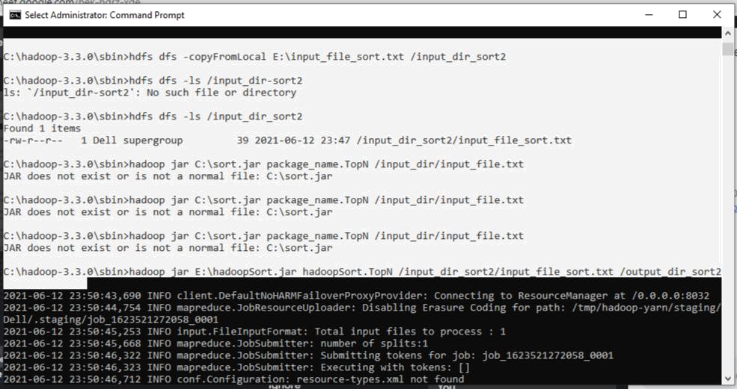

Fig. 20
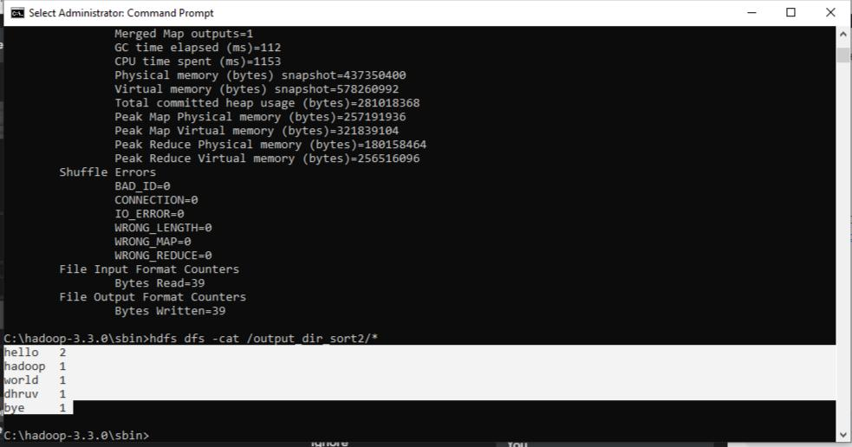

Fig. 21

30

Lab -8

Programme -8

Hadoop Operations - Join Operations

Driver Class

package join;

import org.apache.hadoop.conf.Configured;

import org.apache.hadoop.fs.Path;

import org.apache.hadoop.io.Text;

import org.apache.hadoop.mapred.*;

import org.apache.hadoop.mapred.lib.MultipleInputs; import org.apache.hadoop.util.*;

public class JoinDriver extends Configured implements Tool {

public static class KeyPartitioner implements Partitioner<TextPair, Text> { @Override

public void configure(JobConf job) {}

@Override

public int getPartition(TextPair key, Text value, int numPartitions) {

return (key.getFirst().hashCode() & Integer.MAX_VALUE) %

numPartitions;

}

}

@Override

public int run(String[] args) throws Exception {

if (args.length != 3) {

System.out.println("Usage: <Posts input> <Users input> <output>"); return -1;

}

JobConf conf = new JobConf(getConf(), getClass());

31

conf.setJobName("Join 'Department Emp Strength input' with 'Department Name

input'");

Path AInputPath = new Path(args[0]);

Path BInputPath = new Path(args[1]);

Path outputPath = new Path(args[2]);

MultipleInputs.addInputPath(conf, AInputPath, TextInputFormat.class, Posts.class); MultipleInputs.addInputPath(conf, BInputPath, TextInputFormat.class, Users.class); FileOutputFormat.setOutputPath(conf, outputPath); conf.setPartitionerClass(KeyPartitioner.class);

conf.setOutputValueGroupingComparator(TextPair.FirstComparator.class);

conf.setMapOutputKeyClass(TextPair.class);

conf.setReducerClass(JoinReducer.class);

conf.setOutputKeyClass(Text.class);

JobClient.runJob(conf);

return 0;

}

public static void main(String[] args) throws Exception {

int exitCode = ToolRunner.run(new JoinDriver(), args);

System.exit(exitCode);

}

}

Reducer Class

package join;

import java.io.IOException;

import java.util.Iterator;

import org.apache.hadoop.io.Text;

import org.apache.hadoop.mapred.*;

public class JoinReducer extends MapReduceBase implements Reducer<TextPair, Text, Text, Text> {

@Override

32

public void reduce (TextPair key, Iterator<Text> values, OutputCollector<Text, Text> output, Reporter reporter)

throws IOException

{

Text nodeId = new Text(values.next());

while (values.hasNext()) {

Text node = values.next();

Text outValue = new Text(nodeId.toString() + "\t\t" + node.toString()); output.collect(key.getFirst(), outValue);

}

}

}

Posts Class

package join;

import java.io.IOException;

import org.apache.hadoop.io.*;

import org.apache.hadoop.mapred.*;

public class Posts extends MapReduceBase implements Mapper<LongWritable, Text, TextPair, Text> {

@Override

public void map(LongWritable key, Text value, OutputCollector<TextPair, Text> output, Reporter reporter)

throws IOException

{

String valueString = value.toString();

String[] SingleNodeData = valueString.split("\t");

output.collect(new TextPair(SingleNodeData[3], "0"), new Text(SingleNodeData[9]));

}

}

33

TextPair Class

package join;

import java.io.*;

import org.apache.hadoop.io.*;

public class TextPair implements WritableComparable<TextPair> { private Text first;

private Text second;

public TextPair() {

set(new Text(), new Text());

}

public TextPair(String first, String second) {

set(new Text(first), new Text(second));

}

public TextPair(Text first, Text second) {

set(first, second);

}

public void set(Text first, Text second) {

this.first = first;

this.second = second;

}

public Text getFirst() {

return first;

}

public Text getSecond() {

return second;

}

@Override

public void write(DataOutput out) throws IOException {

34

first.write(out);

second.write(out);

}

@Override

public void readFields(DataInput in) throws IOException { first.readFields(in);

second.readFields(in);

}

@Override

public int hashCode() {

return first.hashCode() * 163 + second.hashCode();

}

@Override

public boolean equals(Object o) {

if (o instanceof TextPair) {

TextPair tp = (TextPair) o;

return first.equals(tp.first) && second.equals(tp.second);

}

return false;

}

@Override

public String toString() {

return first + "\t" + second;

}

@Override

public int compareTo(TextPair tp) {

int cmp = first.compareTo(tp.first);

if (cmp != 0) {

return cmp;

35

}

return second.compareTo(tp.second);

}

- ^^ TextPair

- vv TextPairComparator

public static class Comparator extends WritableComparator {

private static final Text.Comparator TEXT_COMPARATOR = new Text.Comparator();

public Comparator() {

super(TextPair.class);

}

@Override

public int compare(byte[] b1, int s1, int l1,

byte[] b2, int s2, int l2) {

try {

int firstL1 = WritableUtils.decodeVIntSize(b1[s1]) + readVInt(b1, s1); int firstL2 = WritableUtils.decodeVIntSize(b2[s2]) + readVInt(b2, s2);

int cmp = TEXT_COMPARATOR.compare(b1, s1, firstL1, b2, s2, firstL2);

if (cmp != 0) {

return cmp;

}

return TEXT_COMPARATOR.compare(b1, s1 + firstL1, l1 - firstL1, b2, s2 + firstL2, l2 - firstL2);

} catch (IOException e) {

throw new IllegalArgumentException(e);

}

}

}

static {

WritableComparator.define(TextPair.class, new Comparator());

36

}

- ^^ TextPairComparator

- vv TextPairFirstComparator

public static class FirstComparator extends WritableComparator {

private static final Text.Comparator TEXT_COMPARATOR = new Text.Comparator();

public FirstComparator() {

super(TextPair.class);

}

@Override

public int compare(byte[] b1, int s1, int l1,

byte[] b2, int s2, int l2) {

try {

int firstL1 = WritableUtils.decodeVIntSize(b1[s1]) + readVInt(b1, s1); int firstL2 = WritableUtils.decodeVIntSize(b2[s2]) + readVInt(b2, s2); return TEXT_COMPARATOR.compare(b1, s1, firstL1, b2, s2, firstL2); } catch (IOException e) {

throw new IllegalArgumentException(e);

}

}

@Override

public int compare(WritableComparable a, WritableComparable b) { if (a instanceof TextPair && b instanceof TextPair) { return ((TextPair) a).first.compareTo(((TextPair) b).first);

}

return super.compare(a, b);

}

}

  - ^^ TextPairFirstComparator

- vv TextPair

37

}

Users

package join;

import java.io.IOException;

import java.util.Iterator;

import org.apache.hadoop.conf.Configuration; import org.apache.hadoop.fs.FSDataInputStream; import org.apache.hadoop.fs.FSDataOutputStream; import org.apache.hadoop.fs.FileSystem; import org.apache.hadoop.fs.Path;

import org.apache.hadoop.io.LongWritable;

import org.apache.hadoop.io.Text;

import org.apache.hadoop.mapred.*;

import org.apache.hadoop.io.IntWritable;

public class Users extends MapReduceBase implements Mapper<LongWritable, Text, TextPair, Text> {

@Override

public void map(LongWritable key, Text value, OutputCollector<TextPair, Text> output, Reporter reporter)

throws IOException

{

String valueString = value.toString();

String[] SingleNodeData = valueString.split("\t");

output.collect(new TextPair(SingleNodeData[0], "1"), new Text(SingleNodeData[1]));

}

}

Input File - sampleposts.tsv and sampleusers.tsv

38

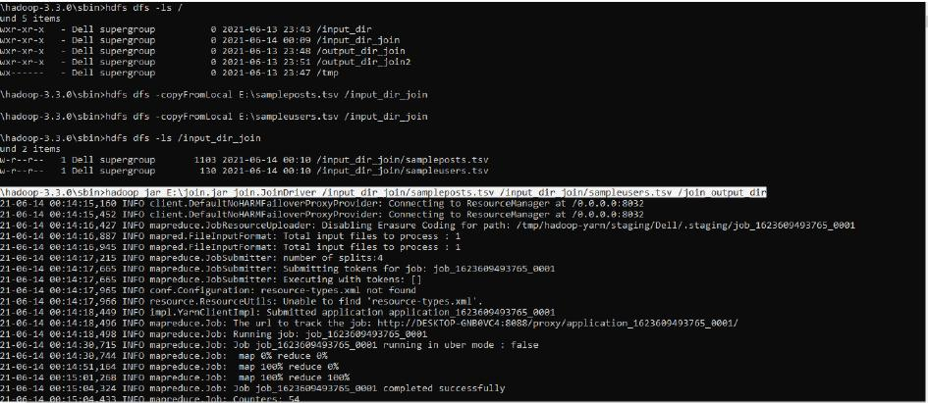

Fig. 22
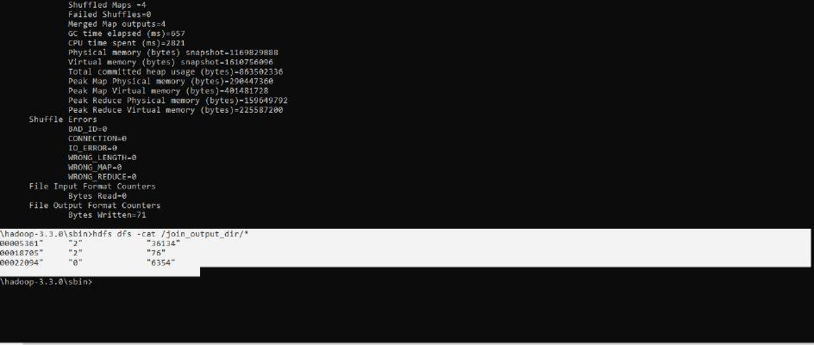

Fig. 23

39

Lab -9

Programme -9

Spark Installation
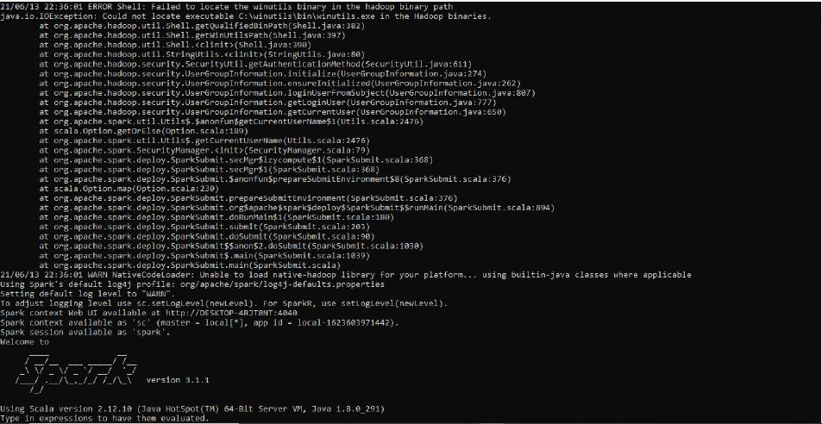

Fig. 23

40

Lab -10

Programme -10

Spark Operations - Word Count

package scalawordcount

import org.apache.spark.SparkConf

import org.apache.spark.SparkContext

import org.apache.spark.rdd.RDD.rddToPairRDDFunctions import scala.collection.immutable.ListMap object wordcount {

def main (args: Array[String]) {

val conf = new SparkConf().setAppName("WordCount").setMaster("local")

val sc = new SparkContext(conf)

val textFile = sc.textFile("input.txt")

val counts = textFile.flatMap(line => line.split(" ")).map(word => (word, 1)).reduceByKey(_ + _)

val sorted=ListMap(counts.collect.sortWith(_._2 > _._2):_*)// sort in descending order based on values

println(sorted)

for((k,v)<-sorted)

{

if(v>4)

{

print(k+",")

print(v)

println()

}

}

}

41

}

Input File - input.txt

Hello World

Hello Hadoop

This is Hello Hadoop test file

Hello Hello Hello This is a test to see The Test Test Test Test Test Hadoop bye.
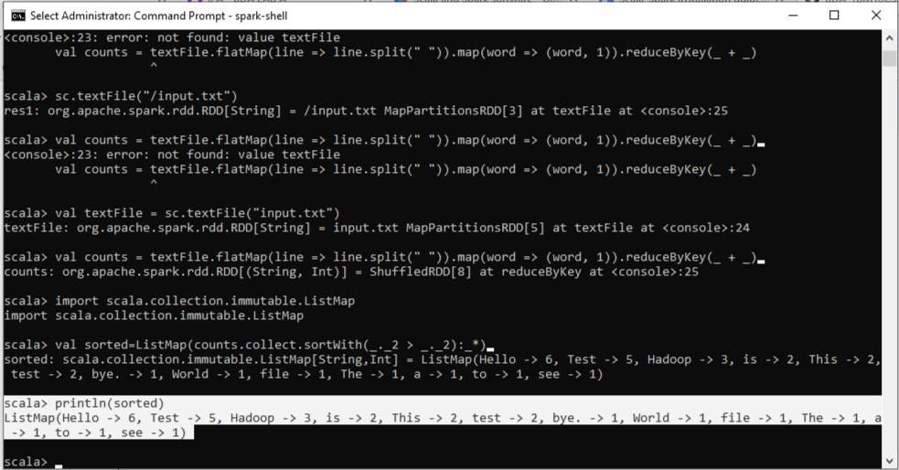

Fig. 24
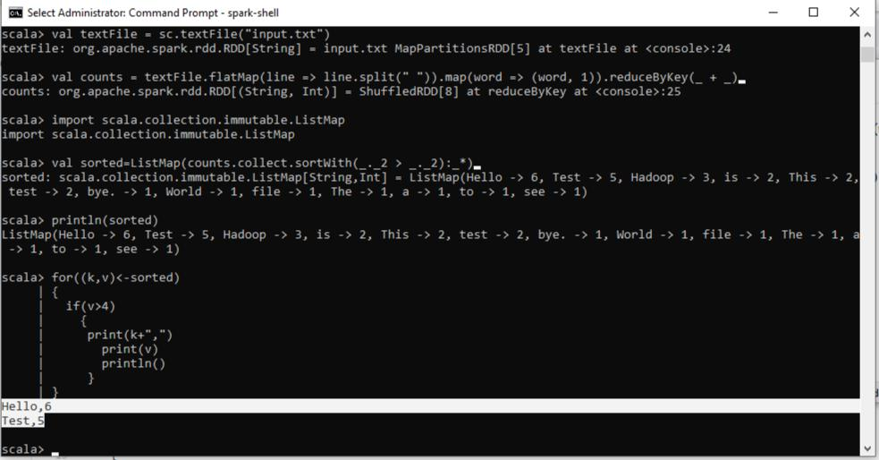

Fig. 25

42

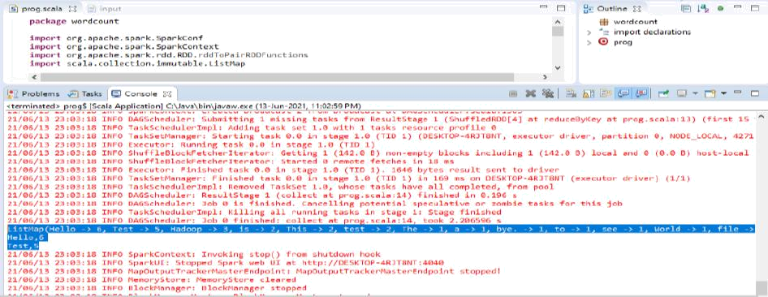

Fig. 26

43

